TODO LIST
- More detailed State-of-art - Tomás
- Requirements elicitation - Tomás
  - Define goals
  - Collect info: docs, interviews
- Functional and non-functional requirements - Flávia
  - https://docs.google.com/document/d/1fXcwtXhv7BgnGWVKQlBTuh6Pfkz5cIbA_1Jp6DqtPfY/edit?usp=sharing
- Actors, use cases and other - Dias
- System Architecture - Diogo
  - Skeleton Structure of the system
- Design mock-ups ASAP - Membro

Elaboration Phase
Requirements elicitation:
- Context and State of The Art (SOA); How the system is expected to be used and what has been done in this context
- Requirements gathering: Sources of information including interviews, questionnaires, user observation, workshops, brainstorming, etc.
- Functional requirements: What the system is supposed to accomplish, for example: business Rules, administrative functions, authentication and authorization levels, reporting, historical data, or Regulatory Requirements.
- Non-functional requirements; Describe how the system works (while functional requirements describe what the system should do), for example: performance (e.g., response time, capacity , availability , recoverability, maintainability , security, data integrity , usability, or interoperability.
- Actors: Describe the target users in your system.
- Use cases: Describe the interaction between users and the system to achieve specific goals. Tip: organize the use cases by packages.
  - UML 2 Use Case Diagrams: An Agile Introduction
-» do not forget assumptions and dependencies.
System architecture:
- Deployment diagram: Describe the hardware the software installed on that hardware and the middleware used to connect machines.
  - Include the technologies used in the system.
  - UML 2 Deployment Diagrams: An Agile Introduction
- [Domain model]: A diagram capturing the main entities and relationships between them may also help in some systems.
  - http://agiledata.org/essays/agileDataModeling.html#InitialDomainModel
- [User interaction]: Design mock-ups as soon as possible.
- Context and State of The Art (SOA);
How the system is expected to be used?
- Network manager to be used by different persons with different levels of permission, those who can edit the state, who can only view the state, those who can’t do nothing.
- In our case it will be used by STIC UA (Serviços de Tecnologias de informação e Comunicação da Universidade de Aveiro) to monitor and control the university network.
- Going to be used under the jurisdiction of STIC, with they’re permissions, ways of working, on “their” Network (which has some state rules. minister rules).
what has been done in this context?
- Currently, when a change needs to be done, one person is needed to go to the computer and type the code on the terminal.
- There is an API that can list the equipments on the network (switches, AP’s, routers, etc) ---> Pelo menos quero acreditar que existe mesmo de verdade

LER: Software-Defined Networking: A Comprehensive Survey - IEEE Journals & Magazine
  - Sacar através da VPN da UA
Related Software
- https://www.itcentralstation.com/categories/network-management-applications
  - Software reviewed by users with: most valuable, how it helped my organization, improvements needed, used previously and why switched, other advice

- Requirements gathering:
Sources of information including interviews, questionnaires, user observation, workshops, brainstorming, etc.
- Interviews with STIC
- Interviews with "orientadores"
- Papers
- related software
- Team meetings

- Functional requirements:
- Graphic Representation of the network
- Intuitive and easy to follow representation of the University infrastructure
- Read-Only Logs
  - Representation of the data modeling in charts
    - Statistics
- View hardware/equipment information
  - Name
  - State
  - Health Monitoring
  - Specifications
  - (...)
- Interface alterations based on access permissions
- IDP Authentication (UA authentication)
- Log register (History)
- Alteration of equipment data
  - conditioned by the level of permission
- Equipment Mapping

- Non-functional requirements;
- Ease to use
- Intuitive
- Safety
- Fault Tolerant
- Usability
- Performance
- Endurance

- Use cases:

- Actors:

- Deployment diagram:

- [Domain model]:

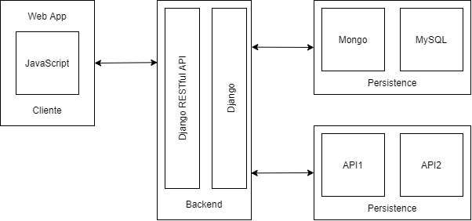
Não terminado. Preciso FeedBack!

